MIDTERM EXAMINATION
TIME ALLOWED: 90’
Subject: Linear Algebra.
No Book and Laptop allowed

1/ Compute 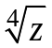, given that 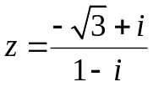.
2/ Find the matrix X such that 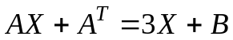, where 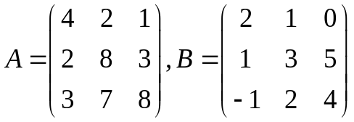.
3/ Find the rank of the matrix 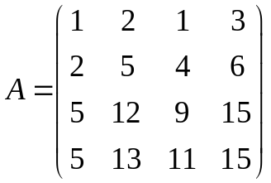.

4/ Determine all real value(s) of m, such that the matrix

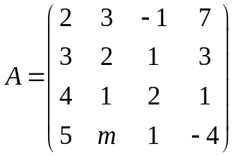 is invertible.
5/ Solve the following system of linear equations
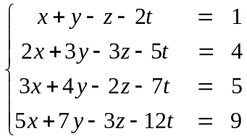

6/ Determine all value(s) of m such that the set

is a spanning set for the vector space 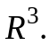

7/ Decide whether the set 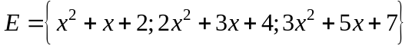 is a basis for the vector
space 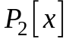. Explain.

-----------------------  -----------------------

